Year 11 Chemistry
AECHE

Part 2

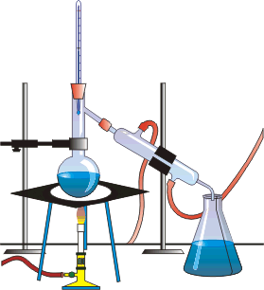

Properties and Structure of materials

Materials are pure substances with distinct measurable properties, including melting and boiling points, reactivity, hardness and density; or mixtures with properties dependent on the identity and relative amounts of the substances that make up the mixture

Classifying Matter:
- Matter – anything that has mass and occupies space.

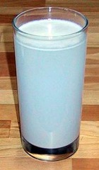
- A substance can be classified as either an element; a compound or a mixture.
- Pure substances such as elements and compounds are uniform in composition.
- Mixtures may be homogenous or heterogenous.

- Homogeneous: Uniform composition and properties throughout

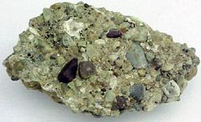
- Heterogeneous: Not uniform in composition and properties

MATTER

Mixtures
(variable composition)

Pure Substances
(constant composition)

Heterogeneous Mixtures
(variable composition and properties throughout)

Solutions
Homogenous Mixtures (Uniform composition and properties throughout)

Elements
(not separable into simpler substances)

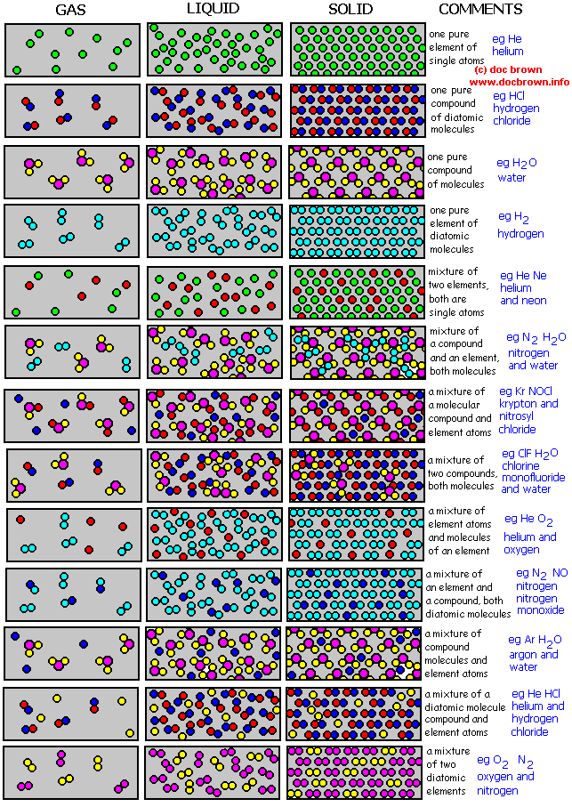 |  |  |     

Pure Substances
- Pure substance – matter which is homogeneous and has a definite fixed composition.
Includes :
- Elements – cannot be separated by chemical means into simpler substances
For example: carbon, oxygen, copper.
- Compounds – composed or two of more elements combined in fixed proportions.
For example: water and carbon dioxide gas.
Compounds have different properties from those of the elements they contain and the elements can only be separated by chemical methods.
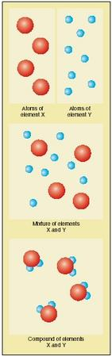

Mixtures
- Mixture – two or more pure substances. The components maintain their own properties and can be separated by physical methods.
- Contain different proportions of the same component substances: pure substances always have the same composition.
- Mixtures can be homogeneous (solutions)
- Homogeneous mixtures – uniform composition and properties throughout e.g. solutions.
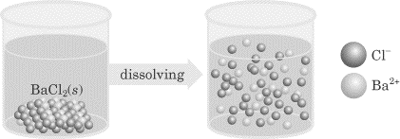
- Solvent: Component of higher concentration. Usually does the dissolving. Usually water
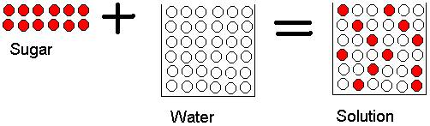
- Solute: Component of lesser concentration. It is the substance that dissolves. Usually solids.
- Aqueous solutions are formed when water is the solvent.
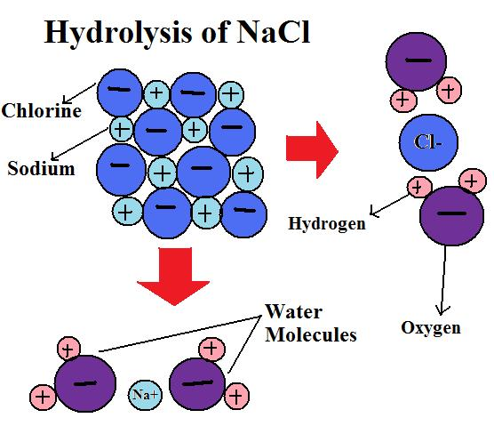

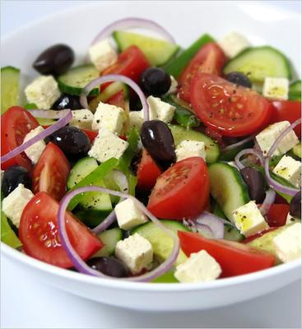
- Mixtures can be heterogeneous
- Heterogeneous mixtures are not uniform in composition and properties throughout.

- Would you classify soup as a heterogeneous or homogeneous mixture? Explain.

PROBLEM SET 1: Answers p 19
- Classify the following as elements (E), compounds (C), solutions (S) or heterogeneous mixtures (HM):
a. molten iron b. carbon dioxide c. lemonade d. air e. water f. salt g. sugar h. nitrogen i. wine j. concrete
- Choose from the following to complete the table below:

Descriptions: Uniform composition throughout
Cannot be separated into simpler substances
Two or more elements chemically combined
Non-uniform composition

Examples: sea water, sugar, gold, limestone, rock, water, fruitcake, cement, oxygen, solder, rubber, salt, brass, aluminium, petrol.

MATTER |  | DESCRIPTION | EXAMPLES
Pure Substance | Elements
 | Compounds
Mixtures | Homogeneous
 | Heterogeneous

- A compound and a solution are both homogeneous substances. How are they different?

- Is a solution different to a mixture? Explain.

- A salt was heated strongly in a crucible until it became molten. An electric current was then passed through it using inert electrodes. A silvery metal formed at one electrode and yellow/green gas was given off at the other. Is the salt an element or a compound? Explain.

NC p140-2 QS 2.1
EC 1.7 p7

Pure substances may be elements or compounds which consist of atoms of two or more elements chemically combined; the formulae of compounds indicate the relative numbers of atoms of each element in the compound.

- Pure substances can exist as elements – only one type of atom. They can be
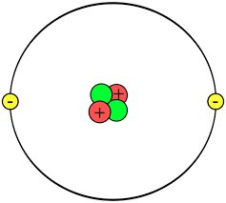
  - Single atoms like helium – He.

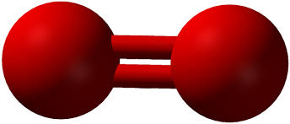

  - Molecules like oxygen – O₂.

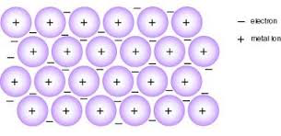
  - Metal lattice.

- Elements are represented by chemical symbols
  - Oxygen – O.
  - Sodium – Na.

- Pure substances can be compounds – two or more elements chemically combined.
- They are groups of atoms held together by strong forces.

- One group of compounds are molecules that are held together by covalent bonds to form small units.
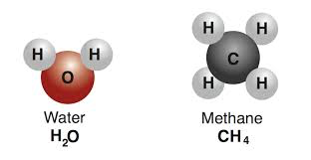

- Compounds are represented by formulae.
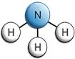
- A formula shows the elements present in the compound and the ratio in which these elements combine.
  - The compound ammonia is composed of hydrogen (H) and nitrogen (N). It has a formula of NH₃ which means that one molecule of ammonia has one atom of nitrogen surrounded by three atoms of hydrogen.

- Another group of compounds are ionic compounds that are held together by ionic bonds.
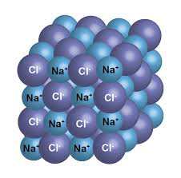
- They form large, three-dimensional lattices.
  - The compound sodium chloride is composed of sodium (Na) and chlorine (Cl). It has a formula of NaCl which means that the ratio of Na to Cl is 1:1 in the crystal lattice.

PROBLEM SET 2: Answers p 19
- The diagrams below are made of atoms, molecules, compounds, elements and mixtures.
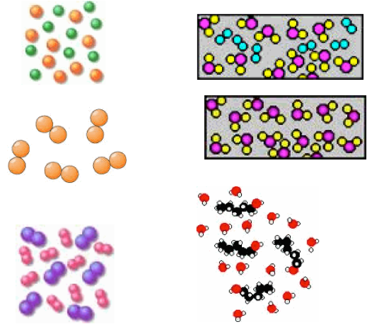
Name the diagrams above.

A D

B E

C F

Classify these naturally occurring substances as elements, mixtures or compounds:

a) air g) soil
b) lemonade h) oxygen gas
c) sea water i) salt
d) sand j) petrol
e) CO2 h) rain
f) sugar i) candle wax

Explain the difference between:

a) An atom and a molecule

b) An ion and an atom

c) A compound and an element

EC 4.1, 4.2 p28
Differences in the physical properties of substances in a mixture, including particle size, solubility, density, and boiling point, can be used to separate them.

Physical and Chemical properties

- Physical properties – properties that can be determined without changing the chemical composition of the substance. These are:
- Melting point
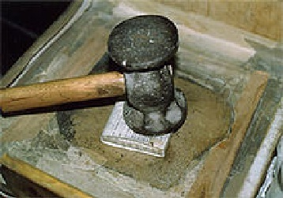
- Boiling point
- Strength
- Density
- Malleability
- Ductility
- Electrical conductivity
- Thermal conductivity
- Solubility
- State
- Hardness
- Colour

- Chemical properties – relate to the ability of a substance to react to form new substances. To determine chemical properties, the chemical composition of the original substance is changed.
- Chemical properties include:
- Decomposition by heat
- Effect of light
- Reaction with water, acids, bases, oxygen and other substances.
- Chemical properties of substances can be used to identify them for their specific uses.

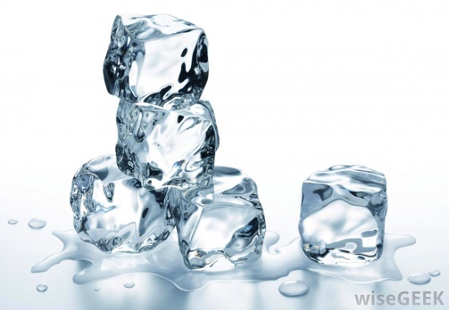
Physical Changes

- Physical changes are changes in the physical properties e.g. colour, melting point etc.
- No new substance is created (no change in chemical composition) during a physical change, although the matter takes a different form.
- Physical changes occur when substances are mixed, but don't chemically react.
- One way to identify a physical change is that such a change may be reversible, especially phase changes. For example, if you freeze an ice cube, you can melt it into water again.

A few examples of physical changes:
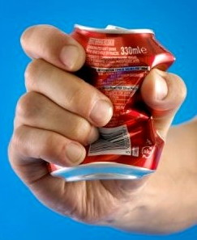
- crushing a can
- melting an ice cube
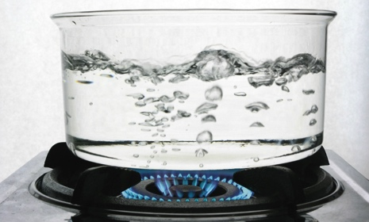
- boiling water
- mixing sand and water
- breaking a glass
- dissolving sugar and water
- shredding paper
- chopping wood
- mixing red and green marbles
- sublimating dry ice
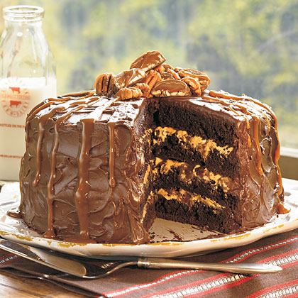
Chemical Changes

- Chemical changes take place on the molecular level.
- Chemical changes involve chemical reactions where at least one new substance is formed with a different chemical composition than the starting materials.
- Typically, a chemical change is irreversible.

A few examples of chemical changes:
- rusting of iron
- combustion (burning) of wood
- metabolism of food in the body
- mixing an acid and a base, such as hydrochloric acid (HCl) and sodium hydroxide (NaOH)
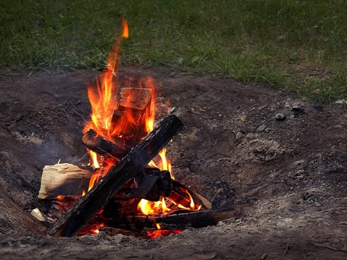
- cooking an egg
- digesting sugar with the amylase in saliva
- mixing baking soda and vinegar to produce carbon dioxide gas
- baking a cake
- electroplating a metal
- using a chemical battery

How to Tell Chemical & Physical Changes Apart

- A chemical change makes a substance that wasn't there before.
- There may be clues that a chemical reaction took place, such as light, heat, colour change, gas production, odour, or sound.
- The starting and ending materials of a physical change are the same, even though they may look different.

Certain observations will indicate that a chemical change has occurred. These are:
- The reaction produced a change in temperature. The temperature could go up (gets hotter – exothermic reaction)) or the temperature could go down (gets colder – endothermic reaction).
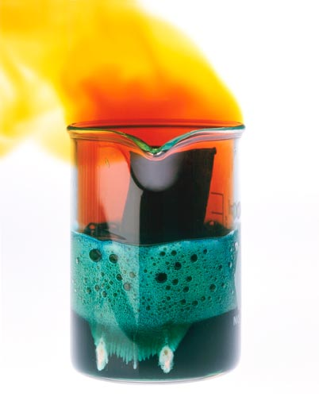
- A solid (called a precipitate) is formed.
- A gas is produced (bubbles).
- Formation of a solid (precipitate).
- A change in colour.
- Formation of a different odour.
- An insoluble solid disappears.

PROBLEM SET 3: Answers p 20
1. Label each process as a physical (P) or chemical (C) change:
a. perfume evaporating on your skin
b. butter melting
c. wood rotting
d. charcoal heating a grill
e. autumn leaves changing colour
f. a hot glass cracking when placed in cold water
g. melting copper metal
h. burning sugar
i. mixing sugar in water
j. digesting food

2. Underline which of the following would NOT be a physical change?
a. freezing water to make ice cubes
b. melting gold to make jewellery
c. burning gasoline in a lawnmower
d. boiling water for soup
e. tearing a piece of aluminium foil

3. Underline which of the following is NOT a physical change?
a. grating cheese
b. melting cheese
c. fermenting of cheese
d. mixing two cheeses in a bowl

4. Label each process as a physical (P) or chemical (C) change:

a. Moth balls gradually vaporize in a closet
b. hydrofluoric acid attacks glass (used to etch glassware)
c. A chef making a sauce with brandy is able to burn off the alcohol from the brandy, leaving just the
brandy flavouring
d. Chlorine gas liquefies at -35 °C under normal pressure
e. hydrogen burns in chlorine gas

PROBLEM SET 3:
1. Which of the following is an example of physical change?
a. Mixing baking soda and vinegar together, and this causes bubbles and foam.
b. A glass cup falls from the counter and shatters on the ground.
c. Lighting a piece of paper on fire and the paper burns up and leaves ashes.
d. Baking a birthday cake for your mother.

2. Which of the following is an example of chemical change?
a. Filling up a balloon with hot air.
b. Taking a glass of water and freezing it by placing it in the freezer.
c. A plant collecting sunlight and turning it into food.
d. Your dog ripping up your homework.

3. Which change can be easily be reversed?
a. Chemical Change
b. Physical Change
c. Both a physical and chemical change
d. Neither a physical or chemical change

4. When a new substance is formed with different properties than the original substance it is called a:
a. Chemical change
b. Physical change
c. Freezing
d. boiling

5. If the chemical properties of a substance remain unchanged and the appearance or shape of a substance changes it is called a:
a. Chemical change
b. Physical change
c. Both a physical and chemical change
d. Neither a physical or chemical change

6. Which is an example of a physical change?
a. Metal rusting
b. Silver tarnishing
c. Water boiling
d. Paper burning

7. What characteristic best describes what happen during a physical change?
a. Composition changes
b. Composition stays the same
c. Form stays the same
d. Mass is lost

8. Which is an example of chemical change?
a. Water freezes
b. Wood is cut
c. Bread is baked
d. Wire is bent

9. Which is not a clue that could indicate a chemical change?
a. Change in colour
b. Change in shape
c. Change in energy
d. Change in odour

10. What property stays the same during physical and chemical changes?
a. Density
b. Shape
c. Mass
d. Arrangement of particle

NC p143-9 QS 2.2
Separating Mixtures
- Very few elements or compounds occur naturally in the pure state. They occur as mixtures.
- Processes can be used to separate these mixtures into their components including:

- Separation by difference in particle size

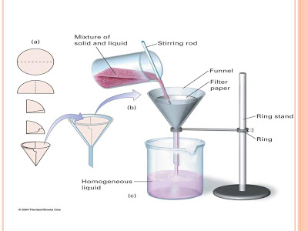
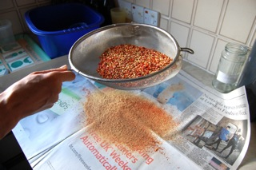
- Sieving: Used to separate large solid particles from suspensions or mixtures of solids. A sieve is a utensil that is a mesh placed over a frame. An example of a sieve is a tea strainer, which is used to separate tea leaves from water. Sieves work because large particles cannot fit through the holes in a sieve, but small particles can. Sieving is often used in preparing food, but it also has other uses. For example, very small sieves can separate viruses from bacteria, while a fishing net could be considered a very large sieve.

- Filtration: One component may be soluble in a solvent, the other may be insoluble – different solubilities. By producing a solution, the insoluble component (residue) is filtered off and the soluble component can be recovered by evaporation.
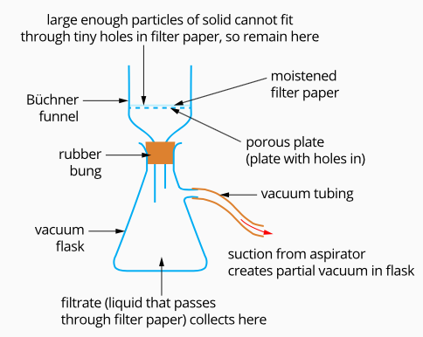

- Separation by difference in boiling point
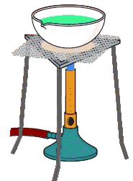

- Vaporisation: The recovery of a dissolved solid from solution that cannot be removed by filtration. The solute is boiled and evaporates leaving the solid behind. Separation is possible because the solute will not evaporate.

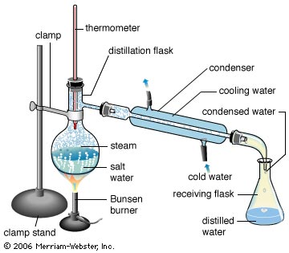
- Distillation (or simple distillation): Used in the purification of liquids; especially with:
- liquids with different boiling points (at least 50°C difference)
- separating a solid from a liquid and retrieving the liquid.
Involves boiling a liquid and cooling the gas produced to condense it back to its liquid state. The liquid with the lowest boiling point boils off first and is collected. The liquid with the higher boiling point remains in the distilling flask.

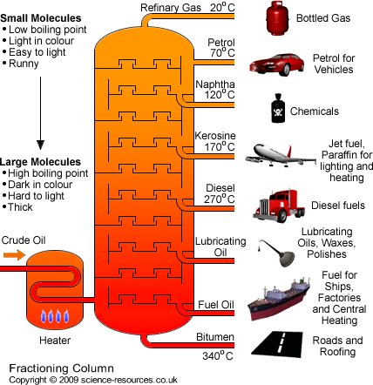
- Fractional distillation: Used to separate two liquids that have boiling points close together. The mixture is heated and the fraction with the lowest boiling point is collected at the top of the column, while the component (fraction) with the highest boiling point is at the bottom of the column. Used to separate crude oil, natural gas processing and the separating of liquid air to obtain oxygen, nitrogen and argon.

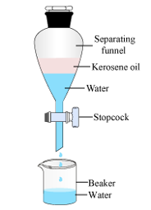

- Separation by density and solubility

- Separating funnel: Used to separate two immiscible (not soluble) liquids, such as water and oil. One component of the mixture forms a layer on top of the other (the less dense one) and the other settles to the bottom of the liquid (the more dense one). The denser liquid can then be collected by opening the stop cork (tap) and the liquid can then be poured off.

- Separation by magnetism and electrostatic attraction

- Magnetic separation: Uses the degree of magnetism or attraction to magnetic fields of a substance. Strongly magnetic material, like iron, can then be separated from non-magnetic material.

- Electrostatic separation: Separate particles on the basis of differences of electrical charge.

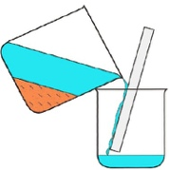
- Other separation techniques

- Decantation: One component of mixture settles to the bottom
of a liquid and the liquid can then be poured off.

- Centrifuge: mixtures are spun at high speed. More dense matter is separated as it spun further.

- Chromatography: A mixture (the mobile phase) is passed over the surface of a selected, inert medium (the stationary phase). The different components of the mixture separate because they stick to the medium with different strengths.

PROBLEM SET 5: Answers p 22
How could the following separations be achieved?
- Sand from a sand-water mixture. __________________________________________________
- Water from a salt solution. ________________________________________________________
- Salt from a sand-salt-water mixture.
____________________________________________________________________________________________________________________________________________________
- Drugs from prepared medicine. _____________________________________________________
- Potassium dichromate from a potassium dichromate-ammonium chloride mixture. The solubilities of potassium dichromate and ammonium chloride are roughly the same in hot water, but potassium dichromate is much less soluble than ammonium chloride in cold water.

________________________________________________________________________________________________________________________________________________________________________________________________________________________________________________________________________________________________________
__________________________________________________________________________
NC p150-5 QS 2.3
EC p24-6
Nanomaterials are substances that contain particles in the size range 1–100 nm and have specific properties relating to the size of these particles which may differ from those of the bulk material.
Nanomaterials
- Nanomaterials are materials of which a single unit is sized (in at least one dimension) between 1 and 1000 nanometers (10⁻⁹ meter) but is usually 1—100 nm (the usual definition of nanoscale).
- Nanomaterials are a type of materials that have particles that are larger than individual atoms, but smaller than the particles of other bulk materials.
- The fast-growing field of nanotechnology involves the engineering and manipulation of matter on an atomic and molecular scale.
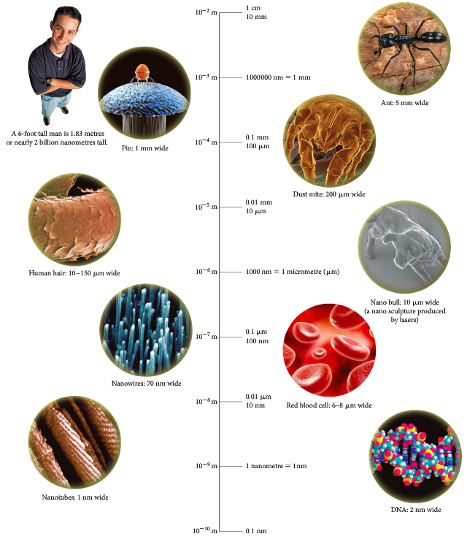

• Atom:
~0.1 nm
• Atoms in a molecule: ~0.15 nm apart
• DNA double-helix: ~2 nm in diameter
• Typical protein: ~10 nm long
• Computer transistor: ~100 – 200 nm wide
• Typical bacteria: ~200 nm long • Human hair: ~50,000 to 100,000 nm in diameter
• Piece of paper: ~100,000 nm thick.

- It is very important to remember that nanomaterials have different chemical and physical properties to that of the bulk material.
- For example, copper metal is transparent on a nanoscale whereas in the bulk it is pink.
- Gold is normally unreactive, whereas it becomes very chemically reactive on a nanoscale.
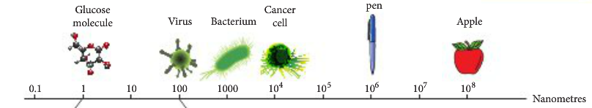

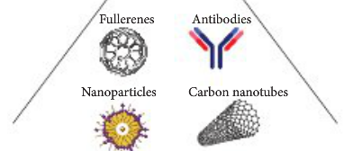

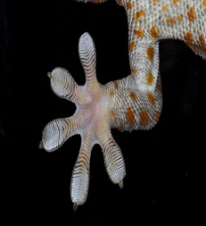
- Materials with structure at the nanoscale often have unique optical, electronic, or mechanical properties.

Natural nanomaterials
- Biological systems often feature natural organic nanomaterials e.g.
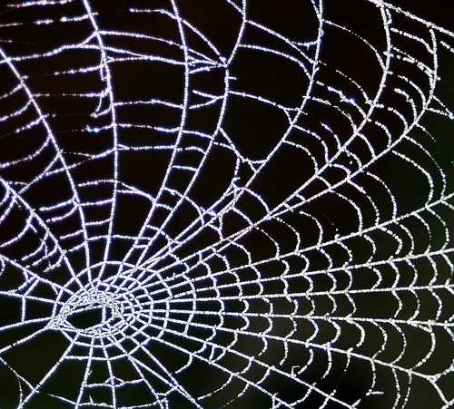
- the structure of viruses,
- the wax crystals covering a lotus leaf,
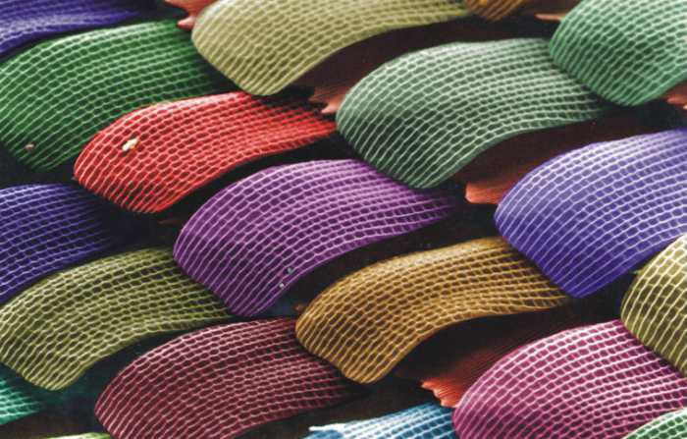
- spider silk,
- the "spatulae" on the bottom of gecko feet,

- some butterfly wing scales,
- natural colloids (milk, blood), horny materials(, claws, beaks, feathers, horns, hair), paper, cotton, nacre, corals

- Natural inorganic nanomaterials occur through crystal growth in the diverse chemical conditions of the earth’s crust e.g.
- clays display complex nanostructures
- volcanic activity can give rise to opals (photonic crystals due to their nanoscale structure)

The field of nanomaterials is loosely organized into
- organic (carbon-based) nanomaterials such as fullerenes,
- and inorganic nanomaterials based on other elements, such as silicon.

Carbon-based nanomaterials

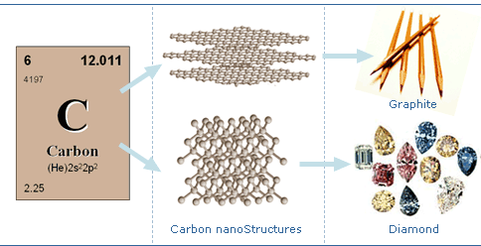
- Carbon comes in many different forms, from the graphite found in pencils to the world's most expensive diamonds.
- In 1980, we knew of only three basic forms or allotropes of carbon, namely
- diamond,
- graphite,
- and amorphous carbon.
- Then, fullerenes and carbon nanotubes were discovered and, in 2004, and graphene joined the club.
- Allotropes are when the atoms of the element are bonded together in a different manner.
Graphene
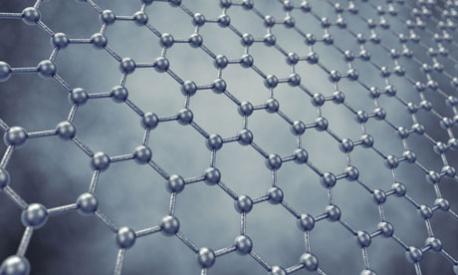
- Graphene is an atomic-scale honeycomb lattice made of carbon atoms.
- Graphene is undoubtedly emerging as one of the most promising nanomaterial because of its unique combination of superb properties.
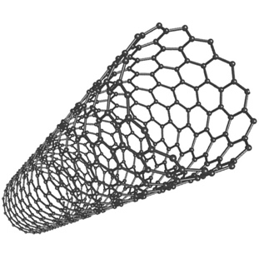
- Existing forms of carbon basically consist of sheets of graphene, either bonded on top of each other to form a solid material like the graphite in your pencil, or rolled up into carbon nanotubes (think of a single-walled carbon nanotube as a graphene cylinder) or folded into fullerenes.

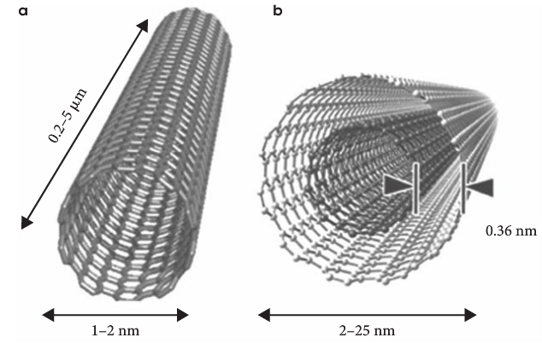

- Early experiments with graphene found that graphene never stops conducting.
- It was also found that electrons travel far faster than electrons in other semiconductors.

Fullerenes
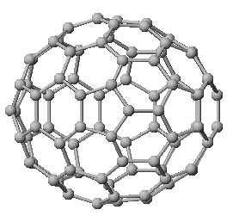
- The fullerenes are a class of allotropes of carbon which conceptually are graphene sheets rolled into tubes or spheres.
- These include the carbon nanotubes (or silicon nanotubes) which are of interest both because of their mechanical strength and also because of their electrical properties.
- An application that is being tested is the use of bucky balls in fibre optics. Because of the perfect spherical shape that they carry, they are able to transmit light.
- The only downfall about bucky balls is that they are expensive to make.

Properties of nanomaterials
- Nanoparticles or nanocrystals made of metals, semiconductors, or oxides are of particular interest for their mechanical, electrical, magnetic, optical, chemical and other properties.
- Nanoparticles are of great scientific interest as they are effectively a bridge between bulk materials and atomic or molecular structures. A bulk material should have constant physical properties regardless of its size, but at the nano-scale this is often not the case.
- Nanoparticles often have unexpected visual properties because they are small enough to confine their electrons and produce quantum effects. For example gold nanoparticles appear deep red to black in solution.

Uses of nanomaterials

- One-dimensional nanomaterials, such as thin films and engineered surfaces, have been developed and used for decades in fields such as electronic device manufacture, chemistry and engineering.
- Sunscreens. ZnO and TiO offer excellent UV protection as bulk materials, but produce an opaque white layer on the skin.
- As nanoparticles, they offer the same UV protection, but are invisible.
- Carbon nanotubes have an extremely high strength and stiffness making them useful in composite materials
- Their electrical conductivity can be varied by altering the dimensions of the tube (they can be conductors or semiconductors), making them useful in electronic applications

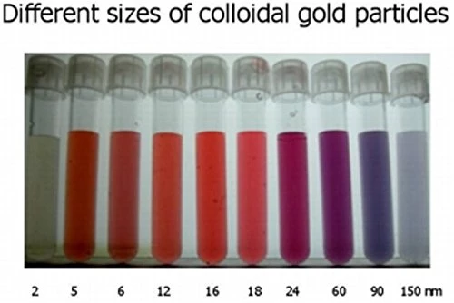
Colloidal Gold
-As a bulk material, gold has a yellow colour and a characteristic metallic lustre

-Colloidal gold (a colloid is intermediate between an solution and a suspension) contains gold nanoparticles

-As nanoparticles, the colour displayed by gold depends on the size of the particles present (optical properties often display quantum effects)

NC p19-22
EC p63-8

PROBLEM SET 1:
- Classify
a. molten iron E b. carbon dioxide C c. lemonade S d. air S e. water C f. salt C g. sugar C h. nitrogen E i. wine S j. concrete HM
- Choose from the following to complete the table below:
MATTER |  | DESCRIPTION | EXAMPLES
Pure Substance | Elements | Cannot be separated into simpler substances | Gold  Oxygen  Aluminium
 | Compounds | Two or more elements chemically combined | Sugar  Water  Salt  Rubber
Mixtures | Homogeneous | Uniform composition throughout | Sea water  Petrol  Brass  Solder
 | Heterogeneous | Non-uniform composition | Limestone  Rock  Fruitcake  Cement

- A compound and a solution are both homogeneous substances. How are they different?
In a compound the constituents are chemically combined, in a solution they are not – can be separated.
- Is a solution different to a mixture? Explain. Solutions are always homogeneous, mixtures can be homogeneous or heterogeneous.
- A salt was heated strongly in a crucible until it became molten. An electric current was then passed through it using inert electrodes. A silvery metal formed at one electrode and yellow/green gas was given off at the other. Is the salt an element or a compound? Explain.
The salt is a compound as it was broken down into simpler components e.g. silver metal and green gas.

PROBLEM SET 2:
Name the diagrams above.
A MIXTURE D MIXTURE
B ELEMENT E COMPOUND
C MIXTURE F MIXTURE
Classify these naturally occurring substances as elements, mixtures or compounds:
a) air MIXTURE g) soil MIXTURE
b) lemonade MIXTURE h) oxygen gas ELEMENT
c) sea water MIXTURE i) salt COMPOUND
d) sand COMPOUND j) petrol COMPOUND
e) CO2 COMPOUND h) rain MIXTURE
f) sugar COMPOUND i) candle wax COMPOUND
Explain the difference between:
a) An atom and a molecule An atom is a single atom, made from protons, neutrons and electrons. A molecule is a group of atoms bonded together.
b) An ion and an atom An atom is a single atom, an ion is an atom or molecule that has acquired a positive or negative charge.
c) A compound and an element A compound contains atoms of different elements chemically combined together in a fixed ratio. An element is a pure chemical substance made of same type of atom.

PROBLEM SET 3:
1. Label each process as a physical (P) or chemical (C) change:
a. perfume evaporating on your skin P
b. butter melting P
c. wood rotting C
d. charcoal heating a grill C
e. autumn leaves changing colour C
f. a hot glass cracking when placed in cold water P
g. melting copper metal P
h. burning sugar C
i. mixing sugar in water P
j. digesting food C

2. Underline which of the following would NOT be a physical change?
a. freezing water to make ice cubes
b. melting gold to make jewellery
c. burning gasoline in a lawnmower
d. boiling water for soup
e. tearing a piece of aluminium foil

3. Underline which of the following is NOT a physical change?
a. grating cheese
b. melting cheese
c. fermenting of cheese
d. mixing two cheeses in a bowl

4. Label each process as a physical (P) or chemical (C) change:

a. Moth balls gradually vaporize in a closet P
b. hydrofluoric acid attacks glass (used to etch glassware) C
c. A chef making a sauce with brandy is able to burn off the alcohol from the brandy, leaving just the brandy flavouring P
d. Chlorine gas liquefies at -35 °C under normal pressure P
e. hydrogen burns in chlorine gas C

PROBLEM SET 4:
1. Which of the following is an example of physical change?
a. Mixing baking soda and vinegar together, and this causes bubbles and foam.
b. A glass cup falls from the counter and shatters on the ground.
c. Lighting a piece of paper on fire and the paper burns up and leaves ashes.
d. Baking a birthday cake for your mother.

2. Which of the following is an example of chemical change?
a. Filling up a balloon with hot air.
b. Taking a glass of water and freezing it by placing it in the freezer.
c. A plant collecting sunlight and turning it into food.
d. Your dog ripping up your homework.

3. Which change can be easily reversed?
a. Chemical Change
b. Physical Change
c. Both a physical and chemical change
d. Neither a physical or chemical change

4. When a new substance is formed with different properties than the original substance it is called a:
a. Chemical change
b. Physical change
c. Freezing
d. boiling

5. If the chemical properties of a substance remain unchanged and the appearance or shape of a substance changes it is called a:
a. Chemical change
b. Physical change
c. Both a physical and chemical change
d. Neither a physical or chemical change

6. Which is an example of a physical change?
a. Metal rusting
b. Silver tarnishing
c. Water boiling
d. Paper burning

7. What characteristic best describes what happen during a physical change?
a. Composition changes
b. Composition stays the same
c. Form stays the same
d. Mass is lost

8. Which is an example of chemical change?
a. Water freezes
b. Wood is cut
c. Bread is baked
d. Wire is bent

9. Which is not a clue that could indicate a chemical change?
a. Change in colour
b. Change in shape
c. Change in energy
d. Change in odour

10. What property stays the same during physical and chemical changes?
a. Density
b. Shape
c. Mass
d. Arrangement of particle

PROBLEM SET 5:
How could the following separations be achieved?
- Sand from a sand-water mixture.
Decantation. For better results, use filtration.
- Water from a salt solution.
Evaporation. If the water need to be collected, use condensation.
- Salt from a sand-salt-water mixture.
Add enough water to dissolve the salt. Then decan the salt solution or filter. Evaporate the water away.
- Drugs from prepared medicine.
Chromatography
- Potassium dichromate from a potassium dichromate-ammonium chloride mixture. The solubilities of potassium dichromate and ammonium chloride are roughly the same in hot water, but potassium dichromate is much less soluble than ammonium chloride in cold water.

Add the mixture to enough hot water to dissolve both solids.
Slowly cool the mixture.
Potassium dichromate is less soluble in colder water and will start to recrystalise.

